**Important Eirthmatic Function in Excel**

* SUMIF FUNCTION
* COUNTIF FUNCTION
* SUMIFS FUNCTION
* COUNTIFS FUNCTION

1. **SUMIF FUNCTION :-**

This function adds numbers together based on a single condition. It has three main parts: range, criteria, and sum_range.

* **Range:** The range of cells that you want to check against the criteria.
* **Criteria:** The condition that must be met for cells to be included in the sum.
* **Sum range:** The actual cells to be added if their corresponding cells in the range meet the criteria.
* **Use case:** Suppose you have a list of sales numbers in column A and the corresponding products in column B. You can use SUMIF to add up sales for a specific product, like "Apples."

**Use sumif function :-**

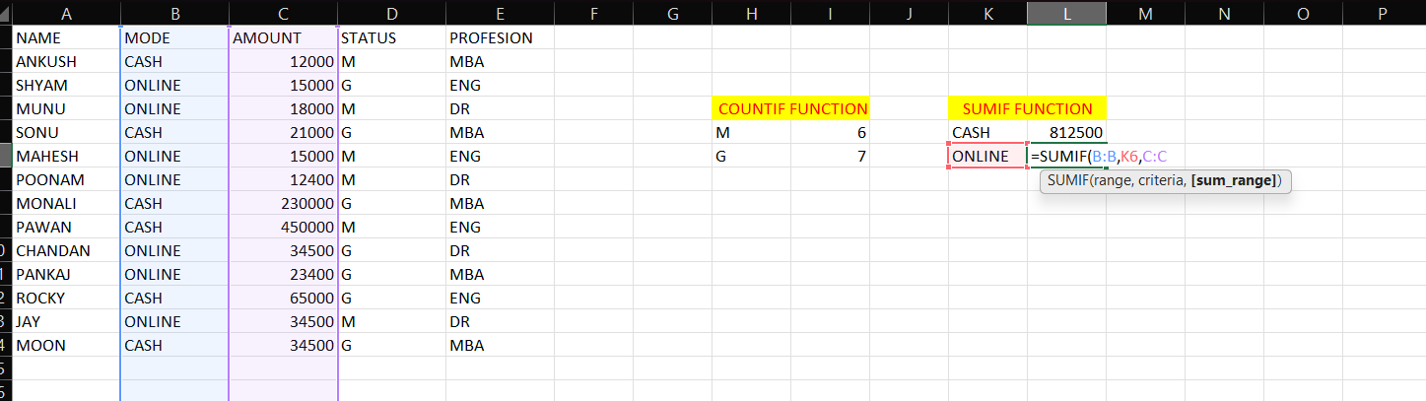

1. **COUNTIF FUNCTION :-**

This function counts the number of cells that meet a single condition. It also has range and criteria as its main arguments.

* **Range:**  The range of cells you want to count.
* **Criteria:** The condition cells must meet to be counted.
* **Use case:**  Imagine you have a list of test scores in column A, and you want to count how many scores are above 80. COUNTIF can do this for you easily.

**Use of counif function :-**

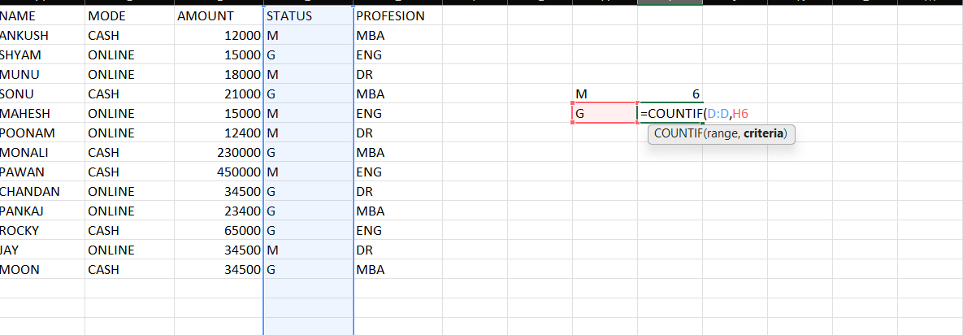

1. **SUMIFS FUNCTION :-**

This function is an extension of SUMIF that allows you to add numbers based on multiple conditions. It can handle multiple criteria sets.

**Sum_range:** The range of cells to be added.

Criteria_range1, Criteria1, [Criteria_range2, Criteria2], Pairs of range/criteria that cells must meet simultaneously to be included in the sum.

Use case: You have sales data with columns for product, month, and region. SUMIFS can help you add sales for a specific product in a certain month and region.

**Use of sumif function :-**

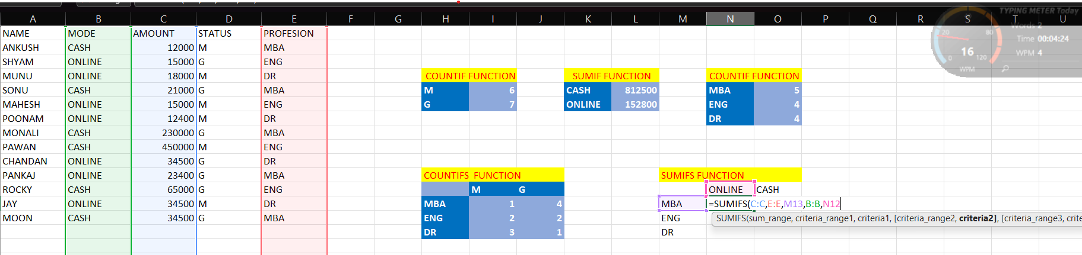

Facing error in it :-

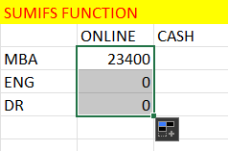

Show Error because of it :-



Resolve this error :-

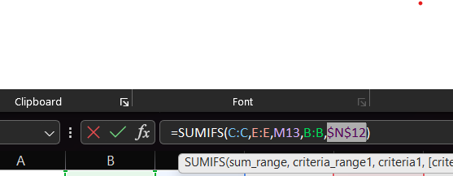

Then output is :-

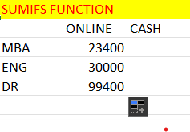

1. **COUNTIFS FUNCTION :-**

Similar to SUMIFS, but it counts the number of cells that meet multiple conditions.

Criteria_range1, Criteria1, [Criteria_range2, Criteria2], ... Pairs of range/criteria that cells must meet simultaneously to be counted.

**After performing all operation 